**QuantiParts and FHG Marine Engineering sign Distributor Agreement.**

QuantiParts BV is proud to announce the addition of FHG Marine Engineering, Inc. (FHG)   
in the USto its Global Distributor Network.

With this agreement, FHG joins the global network of QuantiParts distributors serving classic engines with the highest quality OEM parts to ensure ongoing operational effectiveness and   
to support maintenance, repair, and overhaul, and thus keeping them running.

“We are delighted to partner with QuantiParts in offering high quality OEM spare parts to our customers, ensuring the longevity of their operation and effectiveness of vessel maintenance. Supporting our customers throughout the lifetime of the vessel is fundamental to the FHG business philosophy, and partnering with QuantiParts guarantees we can serve our customers now and into the future.” stated Richard Grennen, CEO, FHG Marine Engineering, Inc.

“Building our global distribution network with partners such as FHG Marine Engineering strengthens our support of vessel installations operating worldwide, and ensures we deliver on our steadfast commitment to keep the engines running.” added Artur van Oerle, Area Manager, for the America’s, QuantiParts B.V.

About FHG Marine Engineering, Inc.

Founded in 2018, FHG Marine Engineering Inc. specializes in marine diesel engine maintenance, repair, and overhaul, delivering planned maintenance and emergency repair services for yachts, cruise ships and commercial vessels. FHG’s team of field services engineers and technicians have years of experience in all aspects of engine overhaul, service, and repair, as well as supporting auxiliary systems, such as sewage and water treatment, fluid management, hydraulics, and electrical systems. FHG offers full workshop services from its facility in Pompano Beach, Florida, serving vessels throughout the USA.

About QuantiParts B.V.

Quantiparts BV is a Wärtsilä company, offering technical support and OEM parts for classic Wärtsilä engines, including Stork Werkspoor Diesel, Deutz KHD, Deutz MWM, Bolnes, Sulzer A/S 4 stroke, SACM, Poyaud, Crepelle, GMT, VASA 14/24. Wärtsilä Diesel Vasa 22, and 200/220 New and remanufactured spare parts are available to keep the engines operating. QuantiParts is known for providing cost efficient solutions and high quality Genine engine parts.

For more information please contact:

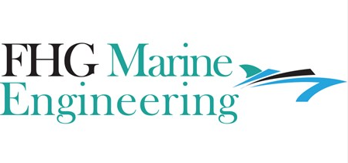  
  
**Yiannik Bennett**

Director of Sales and Marketing LOGO

FHG Marine Engineering, Inc.

2004 NW25th Avenue

Pompano Beach

Florida 33069

yb@fhgmarineengineering.com

Ph : +1(954) 504 2853

**Arthur van Oerle**

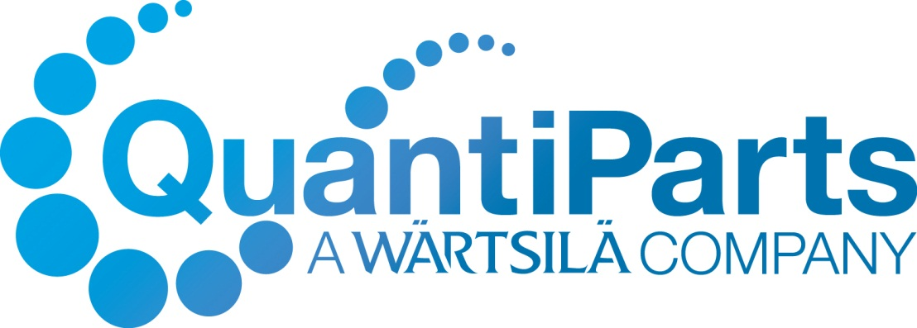

Area Sales Manager – America’s

QuantiParts BV

Innovatiestraat 4

8051 TC Hattem   
The Netherlands

Tel. +31 6 5180 1313

[arthur.vanoerle@quantiparts.com](mailto:arthur.vanoerle@quantiparts.com)

[www.quantiparts.com](http://www.quantiparts.com/)